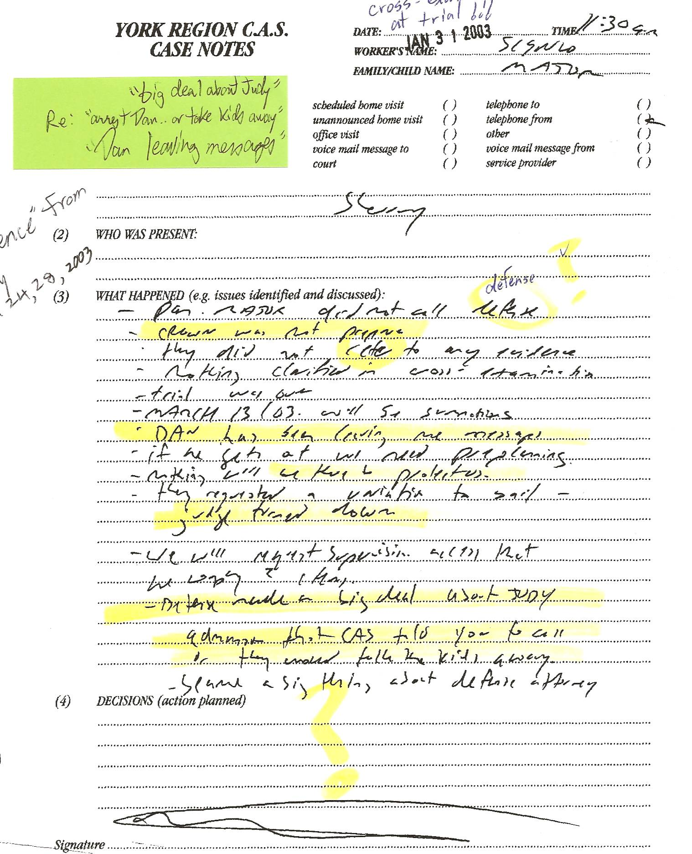

CONTEXT – These notes were after all evidence was heard at Dan’s criminal trial in the previous week. Sherry was the only one to testify. She was exposed as a massive liar. This was witnessed by Sherry’s sister Bernice Kennedy and also Alice Rundell from Yellow Brick House (a shelter that was “providing support” to Sherry). These notes appear to be from a meeting between CAS caseworker Walter Sienko and Sherry. Alice also soon reported back to CAS, noting the extent of her lies.

CAS notes read as follows:
-“Dan Major did not call defense”
-“Crown was not prepared”
-“they did not refer to any evidence”
-“nothing clarified in cross-examination”
-“trial was over”
-“March 13/03 will be summations”
-“Dan has been leaving me messages”
-“if he gets out we need preplanning”
-“nothing will be there to protect us”
-“they requested a variation to bail”
-“judge turned down”
-“we will request supervision access that he … ????”
-“defense made a big deal about Judy”
-“admission that CAS told you to call or they would take the kids away”
-“sp??? a ?? ?? about defense attorney”

Dan’s Notes:
-I didn’t need to call a defense since NOTHING was proven against me – Sherry’s credibility was totally shredded at the cross-examination since she was exposed as having impersonated a doctor for the past five years, amongst many other scams!
-the “preplanning” comment indicates yet again that the CAS ONLY WANTED SHERRY TO HAVE THE KIDS regardless of any concerns they had about Sherry (since giving Dan the kids would be an admission of misjudging Dan, at best, or of outright wrong-doing, at worst.
-“Dan has been leaving me messages” (Dan was on house arrest and had ZERO idea where Sherry was, let alone the ability or desire to leave messages and get thrown back in jail – the CAS, YRP and Sherry all knew this and it is later mentioned in the file!) – this suggests LIES and mental instability!!!)
-Re: “admission that CAS told you…” – this is further evidence that the CAS was FULLY behind my arrest!!! (YRP notes, also obtained through the courts, confirm this)

